**LA GRANDEE INTERNATIONAL COLLEGE**

**Simalchaur, Pokhara**

A project proposal on

**Agro**-**Tech Hub**

**Submitted to**

LA GRANDEE International College

Bachelor of Computer Application (BCA) Program

In the partial fulfillment of the requirement for the degree of BCA affiliated to

Pokhara University

**Submitted by:**

|  |  |  |
| --- | --- | --- |
| **Name** | **Program/Semester** | **PU-Registration No.** |
| Parash Parajuli | BCA 8th SEM | 2021-1-53-0065 |
| Nishchal Sharma | BCA 8th SEM | 2021-1-53-0064 |
| Subash Poudel | BCA 8th SEM | 2021-1-53-0085 |
|  |  |  |

**Date:2025/05/08**

Table of Contents

1. Introduction: 1

2. Problem Statement 2

3. Background Study 3

4. Objectives: 4

5. Program Design: 5

5.1. Methodology:...................................................................................................5

5.2. Block diagram:.................................................................................................6

6. Gantt Chart: 7

7. Deliverables: 8

8. Conclusion: 9

9. References: 10

**List of Figures**

Fig 5.1: Incremental Model 5

Fig 5.2: Block Diagram 6

Fig 7.0: Gantt Chart .......................................................................................................7

# Introduction:

Agriculture serves as the backbone of many economies worldwide, including Nepal. In Nepal, a significant portion of the population relies on agriculture for their livelihoods. Despite its importance, the agricultural sector in Nepal faces various challenges such as limited market access, lack of information, and inefficient supply chains. Traditional farming practices, coupled with inadequate access to modern technology, further exacerbate these challenges.

In recent years, there has been a growing recognition of the potential of technology to address these issues and revolutionize the agricultural sector. Agro-Tech, the application of technology in agriculture, offers promising solutions to improve productivity, sustainability, and profitability in farming practices.

To harness this potential, it is essential to develop integrated platforms that bridge the gap between traditional farming and modern agricultural innovations. By leveraging digital tools such as mobile applications, artificial intelligence, and data analytics, farmers can gain timely access to critical information on weather forecasts, pest control, crop management, and market prices. Such technological interventions not only empower farmers to make informed decisions but also promote transparency, reduce post-harvest losses, and enhance overall efficiency in the agricultural value chain.

# Problem Statement

The current landscape of agricultural support platforms is saturated with solutions that focus primarily on content dissemination rather than delivering a holistic and interactive farming experience. While existing platforms provide access to information and market listings, they often weaknesses the following:

* High Costs:
* Small-scale farmers cannot afford expensive tech solutions.
* Lack of Awareness:
* Many farmers dont know about Agro-Tech or how it can help them.
* Complex Technology:
* User-unfriendly designs make adoption difficult for rural farmers.
* No Training or Support:
* Insufficient guidance on how to use Agro-Tech effectively.

# Background Study

# Agriculture is a central pillar of Nepal’s economy, employing a large portion of the population, particularly in rural areas. However, the sector faces multiple challenges such as outdated farming practices, poor market access, lack of timely agronomic support, and limited use of modern technology. While Agro-Tech solutions have shown promise in improving agricultural productivity and sustainability around the world, their adoption in Nepal remains low. This is due to barriers such as high costs, lack of internet connectivity in remote areas, limited awareness among farmers, and the absence of platforms tailored to the local context. Many existing tools are not user-friendly, are not available in local languages, and do not address the specific needs of Nepali farmers. These gaps have created a digital divide, preventing farmers from benefiting from modern advancements. Recognizing this, the Agro-Tech Hub project was developed to provide an affordable, accessible, and localized digital platform that integrates market access, expert crop advice, financial services, and community learning to support and empower smallholder farmers in Nepal.

Many small farmers in Nepal have very limited resources and face problems like bad weather, pests, and changing market prices. Without proper advice or data, they often rely on guesswork or traditional methods that don’t always work. There is also a lack of coordination between farmers, buyers, cooperatives, and government agencies, which causes delays and low profits. To solve these issues, the Agro-Tech Hub aims to provide a simple, smart platform that connects farmers with the right information, services, and people—helping them improve their income and farming practices.

# Objectives:

These objectives highlight the core aims of the project:

* To help Nepali farmers with a digital tool made for their needs.
* To give farmers real-time farming advice using smart technology.
* To teach and share farming knowledge through a community platform.
* To connect farmers directly with buyers and experts.

# Program Design:

## **Methodology**:

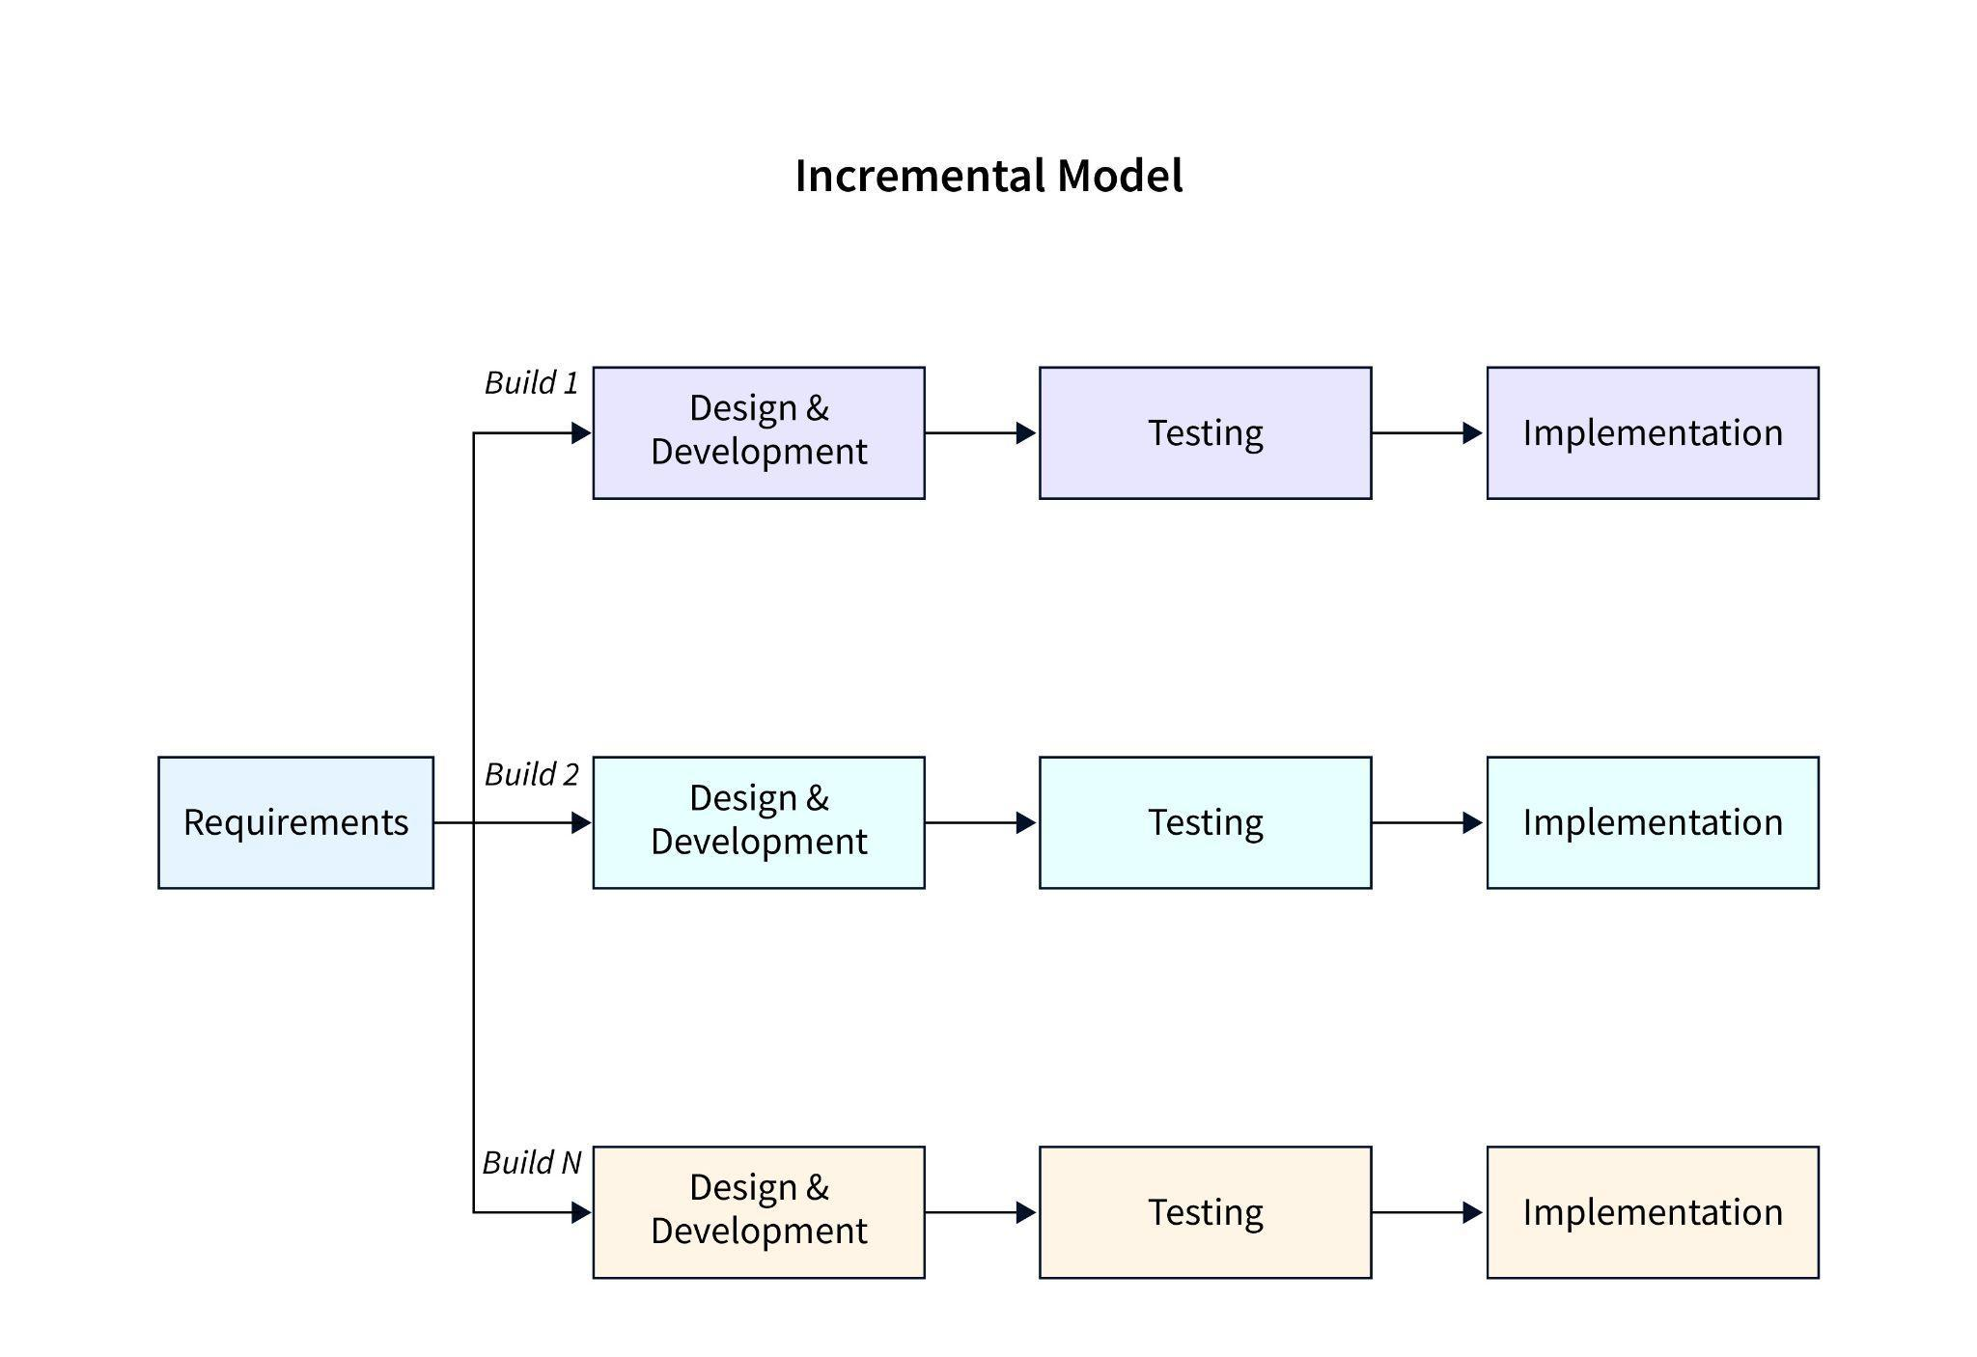

*Figure 5.1 Incremental Model*

The Incremental Model is a software development approach where a product is built in small, functional sections rather than all at once. Each increment adds new features, allowing for early delivery, continuous feedback, and flexibility in changes. This model reduces initial risks, provides users with a working product quickly, and adapts well to evolving requirements. However, it requires careful planning to ensure smooth integration of all parts. Ideal for projects where needs are unclear initially or when early user input is valuable.

## **Block diagram:**

Block diagram of the Agro-Tech Hub is provided below:

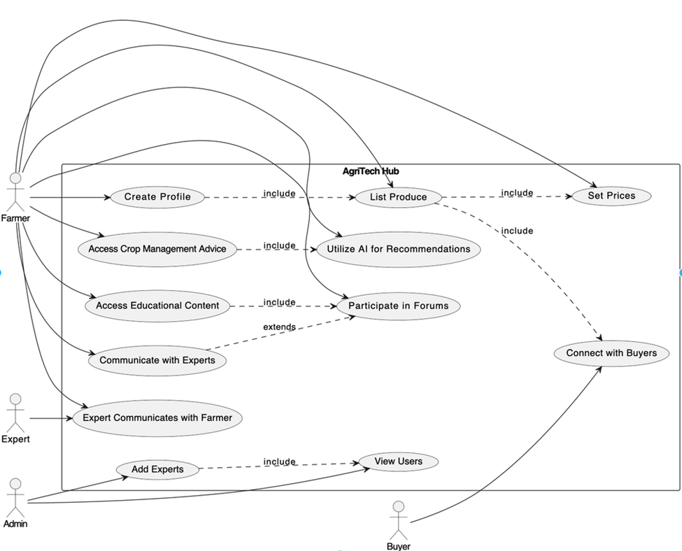

*Fig 5.2 Block Diagram*

# Gantt Chart:

A Gantt chart compares the quantity of work or production that has been performed over a period of time to the amount that was anticipated during those times using a series of horizontal lines.

**Following is the Gantt chart of Agro Tech Hub:**

|  |  |  |  |  |  |  |
| --- | --- | --- | --- | --- | --- | --- |
| SDLC | May | June | | | July | |
| Analysis |  |  | |  |  |  |
| Design |  |  | |  |  |  |
| Coding |  |  |  |  |  |  |
| Testing |  |  | |  |  |  |
| Maintenance |  |  | |  |  |  |
| Documentation |  |  | |  |  |  |

Fig 7.0: Gantt Chart

*Note: The Duration of one interval is of 15 days.

# Deliverables:

To launch Agro-Tech Hub successfully, we'll focus on the following deliverables:

* **A Mobile Application (Agro-Tech Hub App)**
* User-friendly design tailored for farmers.
* Works both online and offline.
* **AI-Based Agronomic Advisory System**
* Provides personalized crop and weather advice.
* Gives AI recommended crop management service using chatbot.
* **Market Linkage Platform**
* Connects farmers directly with buyers.
* Reduces the role of middlemen.
* **Community Learning Feature**
* Allows farmers to share tips, success stories, and questions.
* Encourages peer-to-peer learning.
* **Communication with Experts**
* Experts provides the suggestions to the farmers.
* **Dashboard for Monitoring and Evaluation**
* Helps track user engagement, feedback, and system performance.
* Useful for continuous improvement and reporting.

# Conclusion:

In conclusion, Agro-Tech Hub represents a transformative approach to modernizing agricultural practices for smallholder farmers. By offering a suite of integrated features—ranging from personalized agronomic advice and crop monitoring to market linkages and community engagement. The platform addresses key challenges and enhances farming efficiency. The ability to post crop progress photos and receive tailored guidance not only supports improved agricultural outcomes but also fosters a collaborative environment for knowledge exchange. As a result, Agro-Tech Hub is poised to significantly boost agricultural productivity, facilitate better market access, and drive sustainable development within the farming community. The project's innovative approach demonstrates a promising path forward for integrating technology with agriculture to support and uplift smallholder farmers.

# References:

International Fund for Agricultural Development. (2020). How technology is transforming small-scale agriculture. <https://www.ifad.org>

Food and Agriculture Organization of the United Nations. (2021). Digital agriculture in action: Supporting farmers in developing countries. <https://www.fao.org>